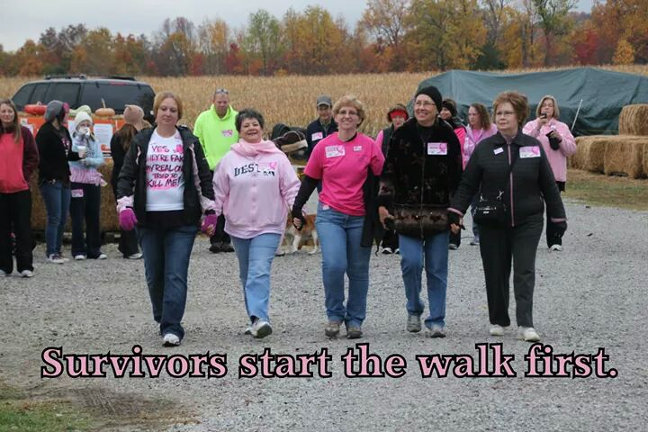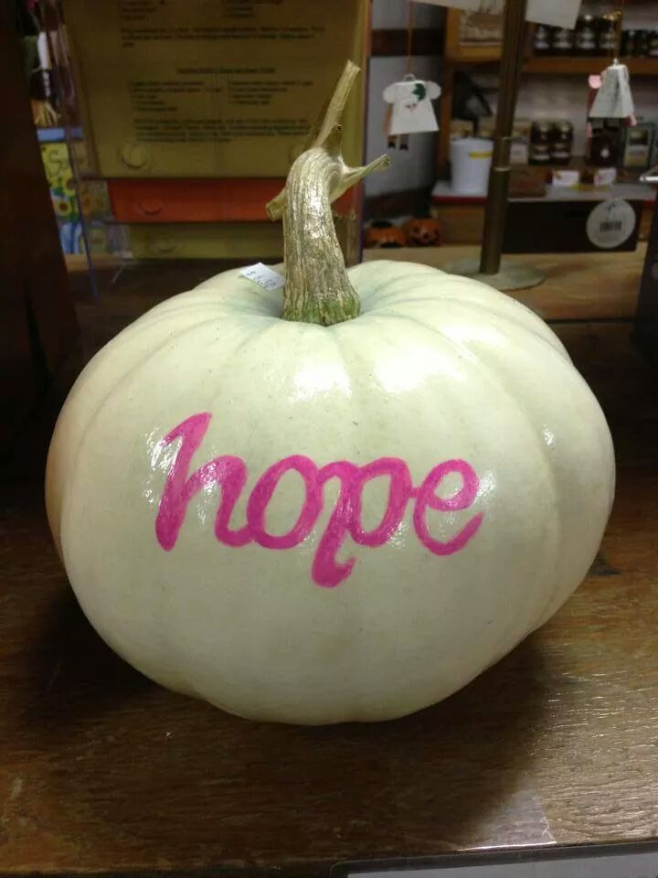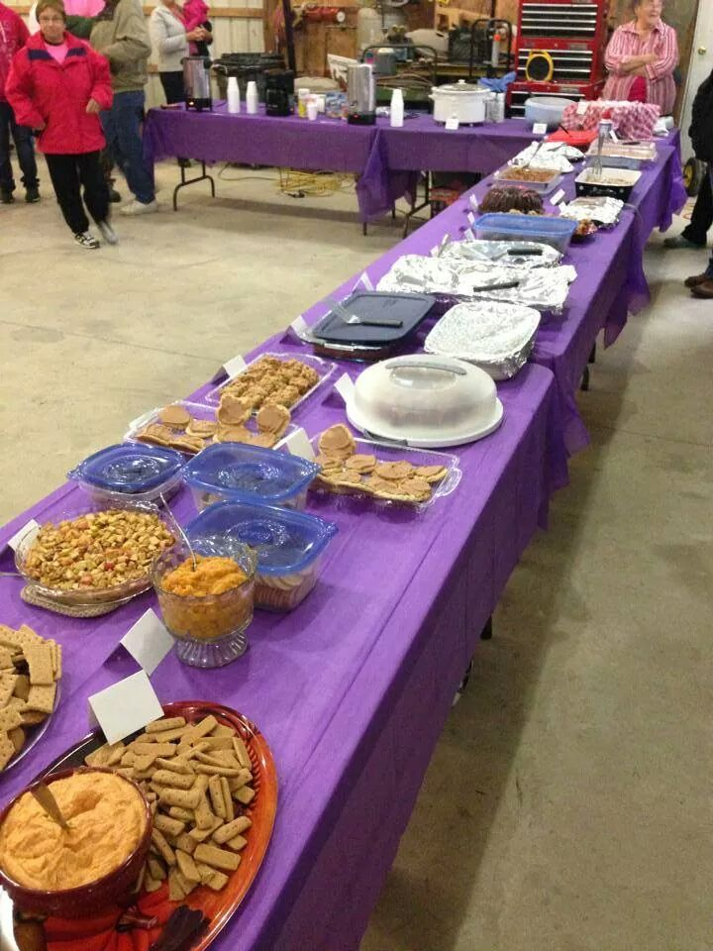

**Harvest of Hope Walk**

**Benefits Relay For Life of Washington County**

Saturday, October 20, 2018

**Cornucopia Farm,** 5444 N Rutherford Hollow Rd, Scottsburg, IN

(Just off Hwy. 56 halfway between Salem & Scottsburg)

Registration: 8:30 a.m. Event Start: 9:00 a.m.

Harvest Brunch immediately following ($5 suggested donation)

To print registration form to bring, go to <http://harvestofhopewalk.org> . **You may also go on Facebook to the “Washington County Harvest of Hope Walk” event and say that you’re coming.**

For more information, call Cornucopia Farm (812-752-6694) or Pam Hawes (812-620-1559).

*Sponsored by Cornucopia Farm LLC and Friends of Wash. Co. Relay For Life*